What is Life? Summative Paper or Project
accepted through Monday December 14th, 2015 for full credit

Students will demonstrate their understanding of Biology by either writing a term paper, or creating a work product and writing an accompanying summary of their work. The paper or project should demonstrate understanding of the following broad topics.
Characteristics of Life/Kingdoms | Biomolecules | Nature/Importance of Water | Cells
Energy: Photosynthesis and Cellular Respiration | Cell Division: Mitosis and Meiosis | Central Dogma (DNA, RNAs, protein) | Genetics and Inheritance
Evolution | Energy: Food Chains and Webs | Symbiotic Interactions | Human Impact
All written components (term paper, work product, explanations) will be submitted as typed documents using Times New Roman 12 point font with 1.5 line spacing to Safe Assign (Blackboard: Summative Paper or Project)
Term Paper | Term Paper Rubric
Students will address the prompt, “What is Life?” by writing a term paper. It is intended and encouraged that students utilize their previous essay responses to draft the paper, and then further develop their paper by citing 3 to 5 additional sources (using in-text citations and MLA format). The paper should be 8-16 paragraphs in length. | The term paper will be scored using the Literacy Design Collaborative Rubric for Informational/Explanatory teaching tasks, and submitted to SafeAssign for grading.
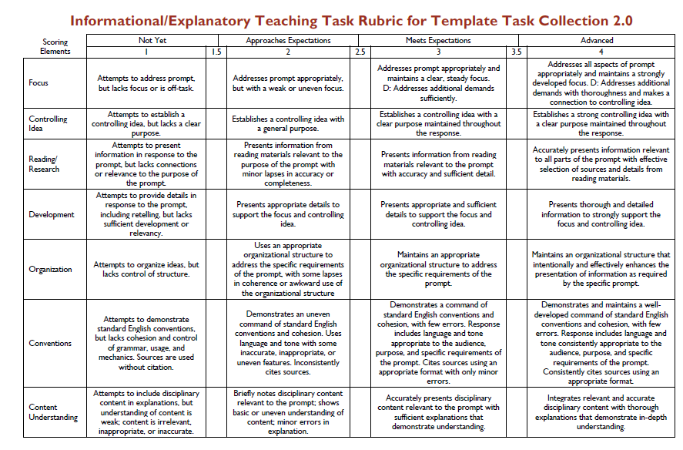
Creative Work Product Options  The work product must be the student’s own work, NOT a reproduction, collection, or collage of other published works.  1. Video: Claymation, dry erase doodle, animated, or acted  - video explains/illustrates key biological concepts  - Submit video by sharing file via google drive with lpeppers2@wcpss.net  - typed script of video submitted via SafeAssign  2. Concept Map  - illustrates and explains concepts and connections  - 4 color minimum  - typed 5-8 paragraph explanation of concept map, connections, color/illustration choices submitted via SafeAssign  3. Illustration, Painting, or Scroll Art (4 color minimum)  - representation of key biological concepts  - typed 5-8 paragraph explanation of how representation relates to key concepts submitted via SafeAssign  4. Hit Single  - Submit audio file by sharing via google drive with lpeppers2@wcpss.net  - 4 color drawing (draft of album cover)  - typed song lyrics and explanation of tune selection, figurative language used in song, and explanation of album artwork, submitted via SafeAssign  5. Long Poem  - typed poem (extended poetic formats include: ballad, epic, free verse, elegy, ode, narrative)  - incorporation/explanation of key concepts  - 4 color accompanying illustration  - 2-4 paragraph description of illustration and connection to poem/concepts  - poem and explanation submitted as a single document via SafeAssign  6. Diorama or 3-dimensional object  - typed 5-8 paragraph explanation of how the objects/setting are representative of key concepts, submitted via SafeAssign  7. Alternative proposals must be approved by Mrs. Peppers no later than Monday 12/7/15. | Creative Work Product Rubric  5 Points - (a WOW product)  - all of the requirements are evident and EXCEEDED  - the product is VERY neatly done and EXTREMELY well organized  - the product shows LOTS of creativity and is colorfully illustrated  4 Points - (What is EXPECTED)  - all of the requirements are evident  - the product is neatly done and well organized  - the product shows creativity and is colorfully illustrated  3 Points – (Almost What is EXPECTED)  - the majority of the requirements are evident  - the product is neatly done and organized  - the product shows some creativity and is illustrated  - completed on time  2 Points – (Sort of What is EXPECTED)  - some of the requirements are evident  - the product is done and sort of organized  - the product shows little creativity and is illustrated  - completed on time  1 Point – (Just got started)  - MANY of the requirements are NOT PRESENT  - the product is VERY POORLY done and POORLY organized  - the product shows little TO NO creativity and THE illustrations IS POORLY DONE  0 Points - (Does not meet Standards)  - Unscorable or no product

This assignment will be weighted as a double exam/project grade in the second quarter, and used to demonstrate understanding of the course as a whole, as well as prepare students for the final exam. The state end of course (EOC) exam will serve as the final exam in WECHS Honors Biology, and will comprise 25% of the course grade.

